PIZZA SALES SQL QUERIES

**A. KPI’s**

1. Total revenue:

SELECT SUM (total_price) AS Total_revenue from [pizza_sales]

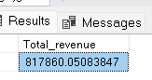

2. Average order value:

select SUM(total_price)/COUNT(DISTINCT order_id) AS Avg_order_value from [pizza sales]

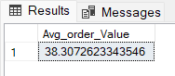

3. Total pizzas sold:

SELECT SUM(quantity) as Total_pizza_sold from [pizza sales]

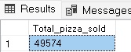

4. Total orders:

SELECT COUNT(DISTINCT order_id) as total_orders from [pizza sales]

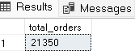

5. Average pizzas per order:

SELECT CAST(CAST(SUM(quantity) AS DECIMAL (10,2))/

CAST (COUNT(DISTINCT order_id) AS DECIMAL (10,2))AS DECIMAL(10,2)) AS Avg_pizzas_per_order FROM [pizza sales]

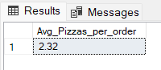

CHART REQUIREMENT:

**B. Daily Trend for Total Orders**SELECT DATENAME(DW, order_date) AS order_day, COUNT(DISTINCT order_id) AS total_orders

FROM [pizza_sales]

GROUP BY DATENAME(DW, order_date)

***Output:***

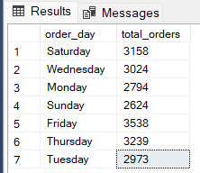

**C. Monthly trend for total orders**

select DATENAME(MONTH, order_date) as Month_Name, COUNT(DISTINCT order_id) as Total_Orders

from [pizza_sales]

GROUP BY DATENAME(MONTH, order_date)

***Output:***

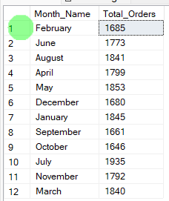

**D. Percentage of sales by pizza category**

SELECT

pizza_category,

CAST(SUM(total_price) AS DECIMAL(10,2)) AS total_revenue,

CAST(SUM(total_price) * 100.0 /

(SELECT SUM(total_price) FROM [pizza sales]) AS DECIMAL(10,2)) AS PCT

FROM [pizza sales]

GROUP BY pizza_category;

***Output:***

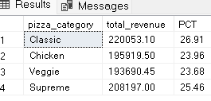

**E. Percentage of sales by pizza size**

SELECT

pizza_size,CAST(SUM(total_price)AS DECIMAL(10,2)) AS Total_revenue,

CAST(SUM(total_price) * 100.0 /

(SELECT SUM(total_price) FROM [pizza sales])AS DECIMAL(10,2)) AS PCT

FROM [pizza sales]

GROUP BY pizza_size

ORDER BY pizza_size

***Output:***

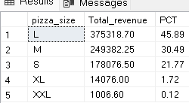

**F. Total Pizzas Sold by Pizza Category**

SELECT pizza_category, SUM(quantity) as Total_Quantity_Sold

FROM [pizza_sales]

WHERE MONTH(order_date) = 2

GROUP BY pizza_category

ORDER BY Total_Quantity_Sold DESC

***Output:***

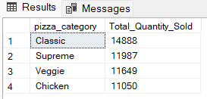

**G. Top 5 Pizzas by Revenue:**

SELECT TOP 5 pizza_name, SUM (total_price) AS total_revenue FROM [pizza sales]

GROUP by pizza_name

ORDER by total_revenue DESC

***Output:***

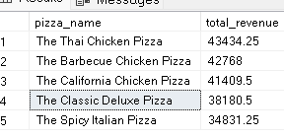

**H. Bottom 5 pizzas sold by revenue**

SELECT TOP 5 pizza_name, SUM (total_price) AS total_revenue FROM [pizza sales]

GROUP by pizza_name

ORDER by total_revenue ASC

***Output:***

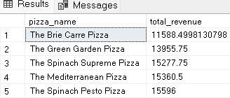

**I. Top 5 pizzas sold by total quantity**

SELECT TOP 5 pizza_name, SUM (quantity) AS total_quantity FROM [pizza sales]

GROUP by pizza_name

ORDER by total_quantity DESC

***Output:***

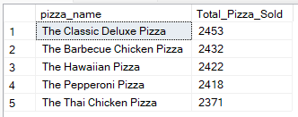

**J. Bottom 5 pizzas sold by total quantity**

SELECT TOP 5 pizza_name, SUM (quantity) AS total_quantity FROM [pizza sales]

GROUP by pizza_name

ORDER by total_quantity ASC

***Output:***

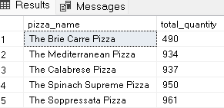

**K . Top 5 pizzas sold by total orders**

SELECT TOP 5

pizza_name,

COUNT(DISTINCT order_id) AS total_orders

FROM [pizza sales]

GROUP BY pizza_name

ORDER BY total_orders DESC;

***Output:***

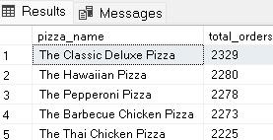

**L . Bottom 5 pizzas sold by total orders**

SELECT TOP 5

pizza_name,

COUNT(DISTINCT order_id) AS total_orders

FROM [pizza sales]

GROUP BY pizza_name

ORDER BY total_orders ASC;

***Output:***

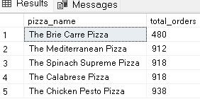

***NOTE***

If you want to apply the pizza_category or pizza_size filters to the above queries you can use WHERE clause. Follow some of below examples

SELECT Top 5 pizza_name, COUNT(DISTINCT order_id) AS Total_Orders

FROM [pizza_sales]

WHERE pizza_category = 'Classic'

GROUP BY pizza_name

ORDER BY Total_Orders ASC